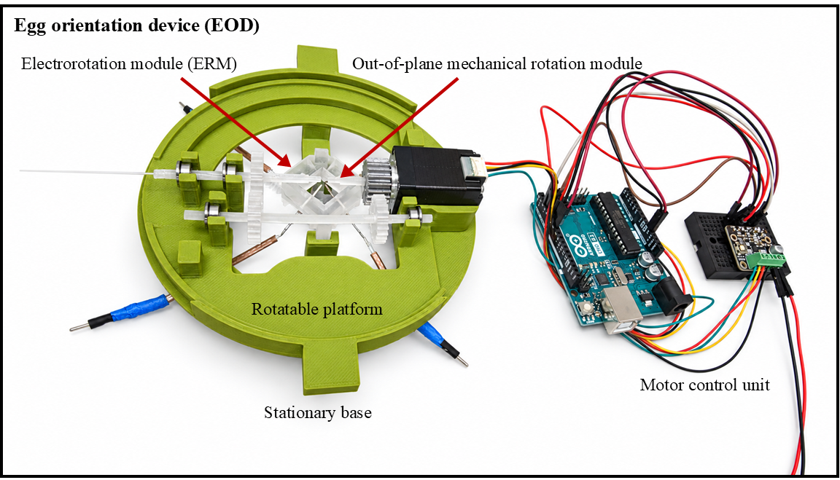
Figure S1. Egg orientation device and experimental setup. Assembled egg orientation device (EOD), showing the electrorotation module (ERM), out-of-plane mechanical rotation module, rotatable platform, stationary base, and motor control unit.

Table S1. Estimated component costs of the egg orientation device (EOD).
Component | Manufacturer, model, or material | Estimated cost (USD)
3D-printed structural components | PLA filament and photopolymer resin | 10
Function generator | Siglent, SDG2000X series | 574
Four-output DC power supply | FLIR Extech, 382270 | 679
Phase-splitter printed circuit board | Custom-built PCB and associated electronic components | 200
Rotating motor | N20 Motor with encoder or stepper motor NEMA-8 | 20
Total estimated component cost |  | 1483

Table S2. Printing settings for 3-D Resin Printer.
Parameters | Settings
Printer model | CADworks3D Microfluidics 285D
Slicer name | Utility
Slicer version | 6.4.4.t12
Layer height (mm) | 0.03
Exposure time (s) | 0.8
Base curing (s) | 25
Gap adjustment (mm) | -0.25
Base layer | 1
Buffer layer | 4
Power (%) | 100
Print delay (s) | 90

Definitions
Layer Height: The thickness of each layer in the print.
Exposure Time: The amount of time for UV curing (seconds) per layer.
Base curing: Curing time for base layers.
Gap adjustment: Adjust the thickness of the first layer.
Base layer: Define the number of base layers.
Buffer layer: Set the Number of buffer layers.
Power: At 100% is the existing brightness of the light engine.
Print delay: For the first layer, the build plate stays for at least 1 sec. Then cure.

Printing post-processing
We placed the device in a zip lock filled with 99% isopropyl alcohol (IPA) and cleaned it in an ultrasonic water bath for 2 min to remove residual resin. The devices were subsequently rinsed with fresh 99% IPA followed by deionized water to remove remaining uncured resin. After air-drying, the devices underwent a final 1-min curing step under 405 nm UV light.

Phase splitter schematics

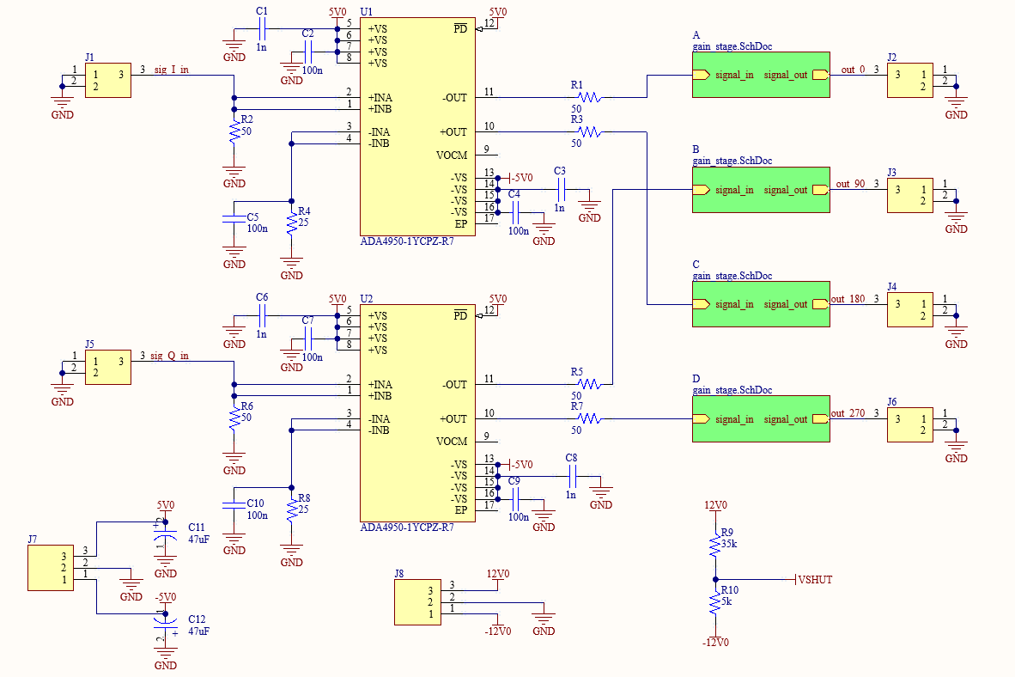
Figure S2. Circuit schematic of the custom four-phase signal-generation PCB. Two quadrature input signals (I and Q, separated by 90°) are split into complementary signal pairs using ADA4950-1 amplifiers and routed through four gain stages (A–D) to provide the outputs labeled 0°, 90°, 180°, and 270° for electrorotation.

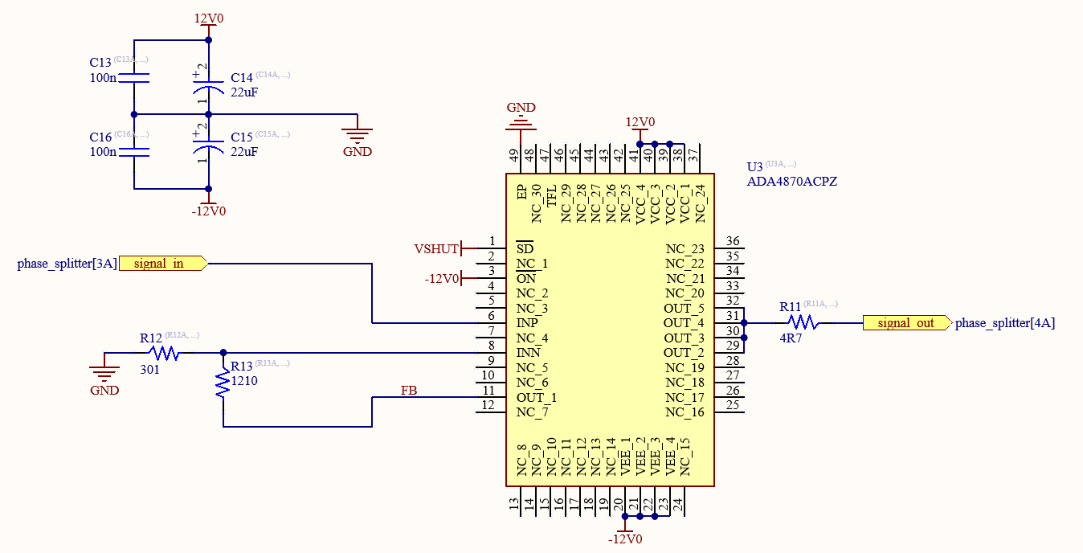
Figure S3. Circuit schematic of an individual output gain stage. Each of the four channels uses an ADA4870 amplifier in a non-inverting configuration, powered by ±12 V supplies. The schematic shows the feedback resistor network, supply-decoupling capacitors, shutdown-control connection, and 4.7 Ω series resistor output. The same circuit is repeated in gain stages A–D of the four-phase signal-generation PCB.

Table S3. Bill of materials for the four-phase signal-generation PCB.
Designator | Part Number | Value | Description | Quantity
U1, U2 | ADA4950-1YCPZ-R7 | N/A | Differential amplifier | 2
U3A, U3B, U3C, U3D | ADA4870ACPZ | N/A | High voltage drive amplifier | 4
C1, C3, C6, C8 | C0603X102J4RECAUTO | 1nF | Power supply decoupling capacitor | 4
C2, C4, C5, C7, C9, C10, C13A, C13B, C13C, C13D, C16A, C16B, C16C, C16D | CC0603JRX7R9BB104 | 100nF | Power supply decoupling capacitor, input matching | 14
C11, C12 | TAJB476K010RNJ | 47uF | Bulk power supply decoupling capacitor | 2
C14A, C14B, C14C, C14D, C15A, C15B, C15C, C15D | TAJB226K020RNJ | 22uF | Bulk power supply decoupling capacitor | 8
J1, J2, J3, J4, J5, J6 | 73100-0105 | N/A | BNC connector | 6
J7, J8 | TB002-500-03BE | N/A | Screw terminals for power supply | 2
R1, R2, R3, R5, R6, R7 | TNPW060350R0DEEA | 50 Ω | Impedance matching resistor | 6
R4, R8 | RP0603BRD0725RL | 25 Ω | Impedance matching resistor | 2
R9 | RMCF0603FT34K8 | 35k Ω | Shutdown control | 1
R10 | RT0603BRE075KL | 5k Ω | Shutdown control | 1
R11A, R11B, R11C, R11D | RC0603FR-134R7L | 4.7 Ω | Output stability resistor | 4
R12A, R12B, R12C, R12D | ERJ-3EKF3010V | 301 Ω | Gain setting resistor | 4
R13A, R13B, R13C, R13D | RC0603FR-071K21L | 1.21 KΩ | Gain setting resistor | 4
PCB | Custom PCB | N/A | Printed circuit board | 1

